2D XY model
$T_{c}≈0.89301$

T tensor definition
$$T_{ijkl}=\frac{\sqrt{I_{i}(βJ)I_{j}(βJ)I_{k}(βJ)I_{l}(βJ)}}{2M+1}δ_{mod\left(i+j-k-l,q\right)}$$
where $I_{m}$ is the modified Bessel function of the first kind of real order, and
$$m=-M,-M+1,…, M-1, M$$
M is the Fourier cutoff.

HOTRG Results:
Free energy per site f
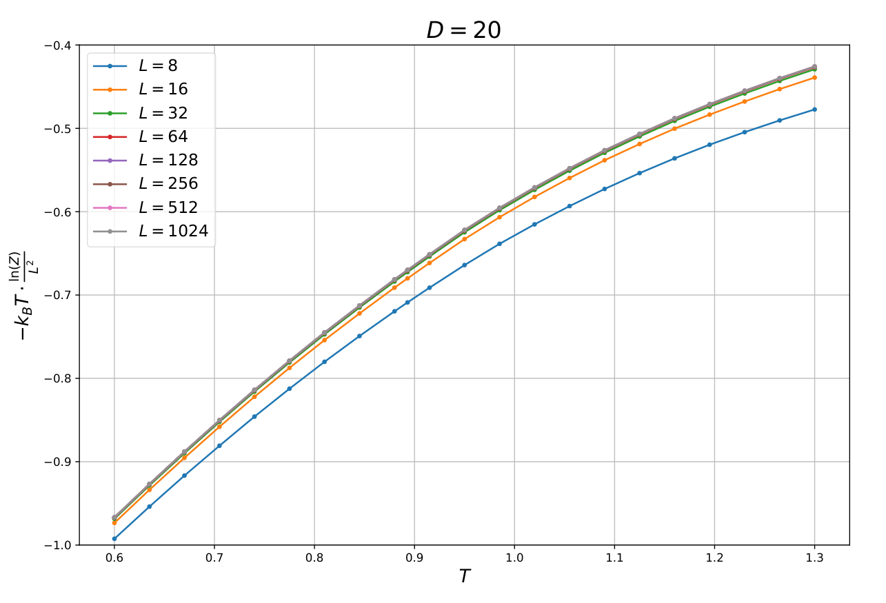

Correlation length per site $ξ/L$
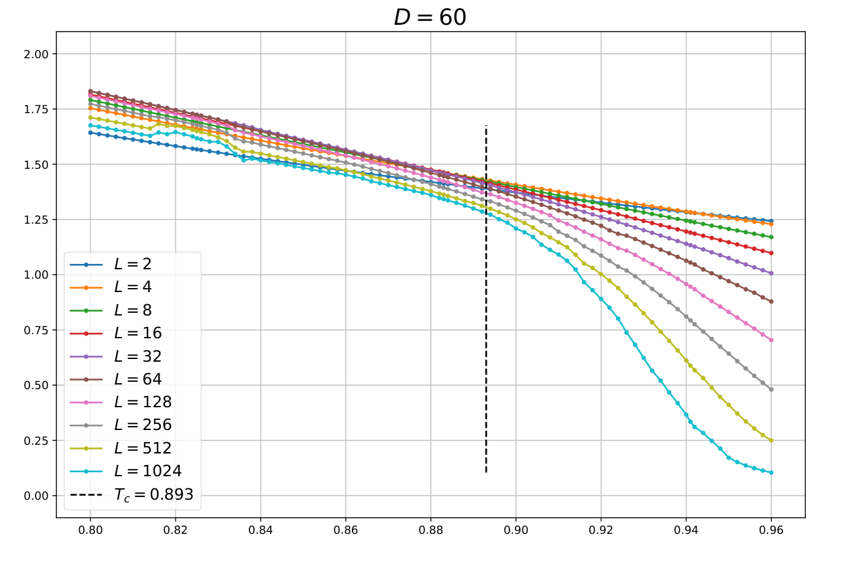
$$T$$
$$\frac{ξ}{L}$$

Conformal Tower
Schematic graph for PBC, TBC, TBC_last:
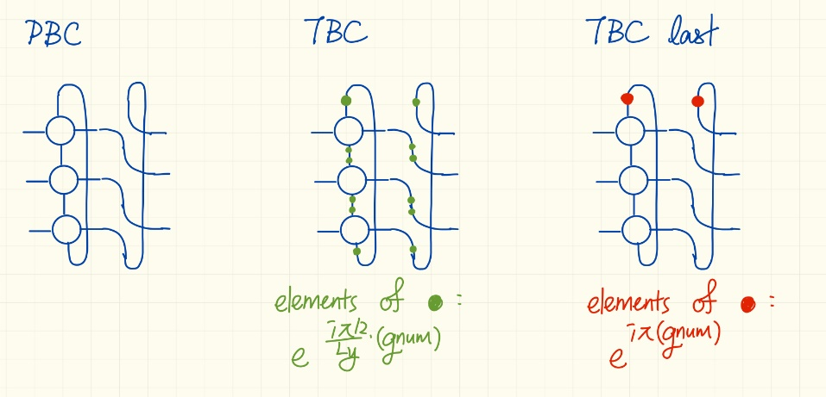
$$x_{α}^{\left(q_{qnum}, PBC\right)}=Re\left[E_{α}^{\left(q_{qnum},PBC\right)}-E_{0}^{\left(q_{0},PBC\right)}\right]×\frac{L_{y}}{2π}$$
$$x_{α}^{\left(q_{qnum}, TBC\right)}=Re\left[E_{α}^{\left(q_{qnum},TBC\right)}-E_{0}^{\left(q_{0},PBC\right)}\right]×\frac{L_{y}}{2π}$$
$$s_{α}^{\left(q_{qnum}\right)}=-Im\left[E_{α}^{\left(q_{qnum}\right)}\right]×\frac{L_{x}L_{y}}{2π}$$
The scaling dimensions should be $x_{W_{±2} }=x_{0}^{\left(m_{±2}, PBC\right)}$, $x_{V_{\frac{1}{2}}^{s} }=x_{0}^{\left(m_{0}, TBC\right)}$.
